APPSERVER & WEBSERVER

- Install nginx and run nginx on port number 81.
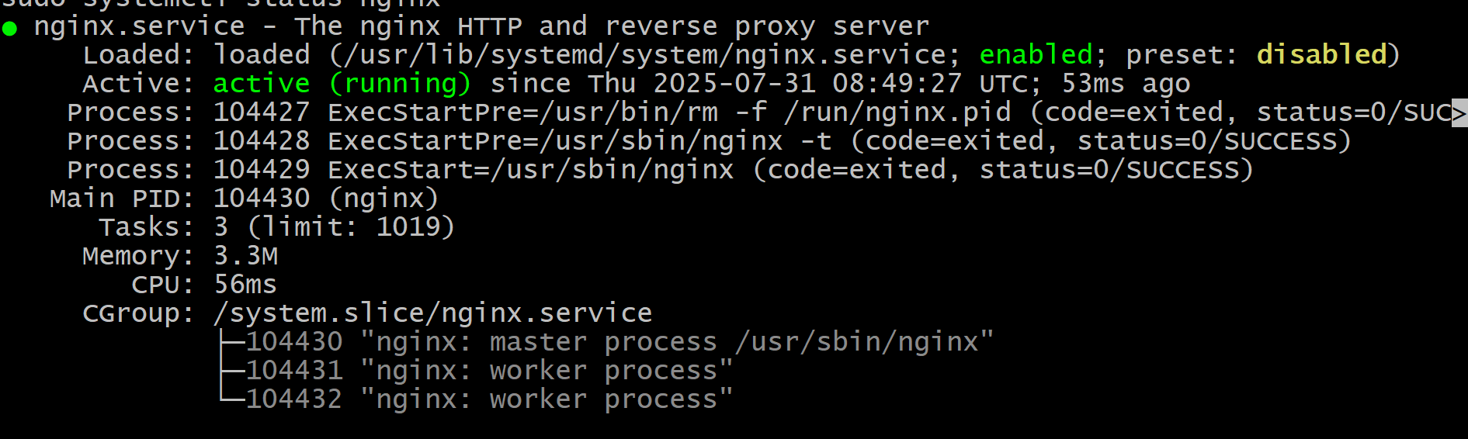
- Deploy a sample index.html file on nginx.
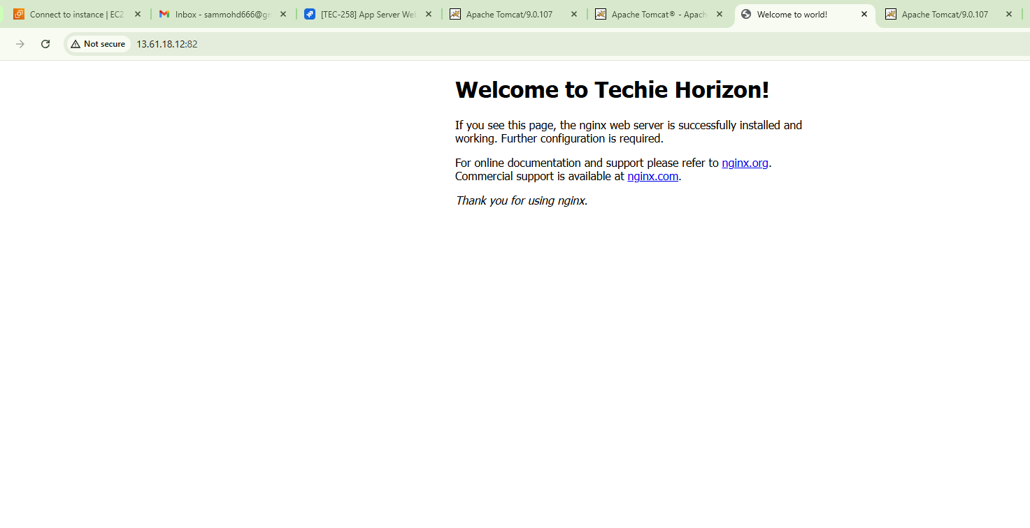
- Install Apache and run Apache on port number 82

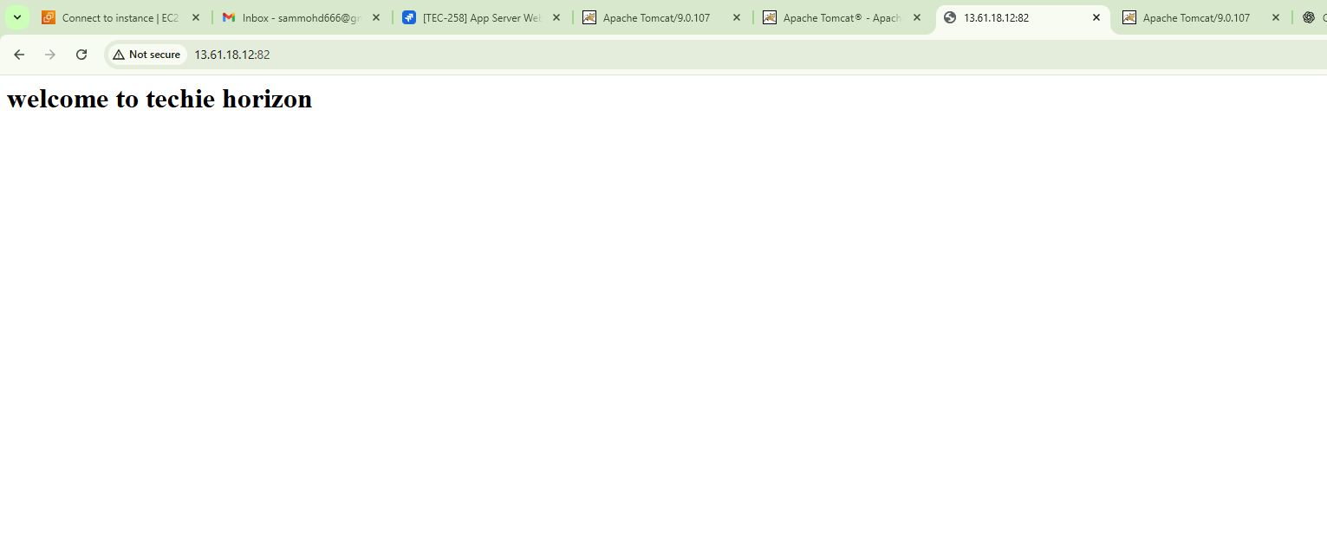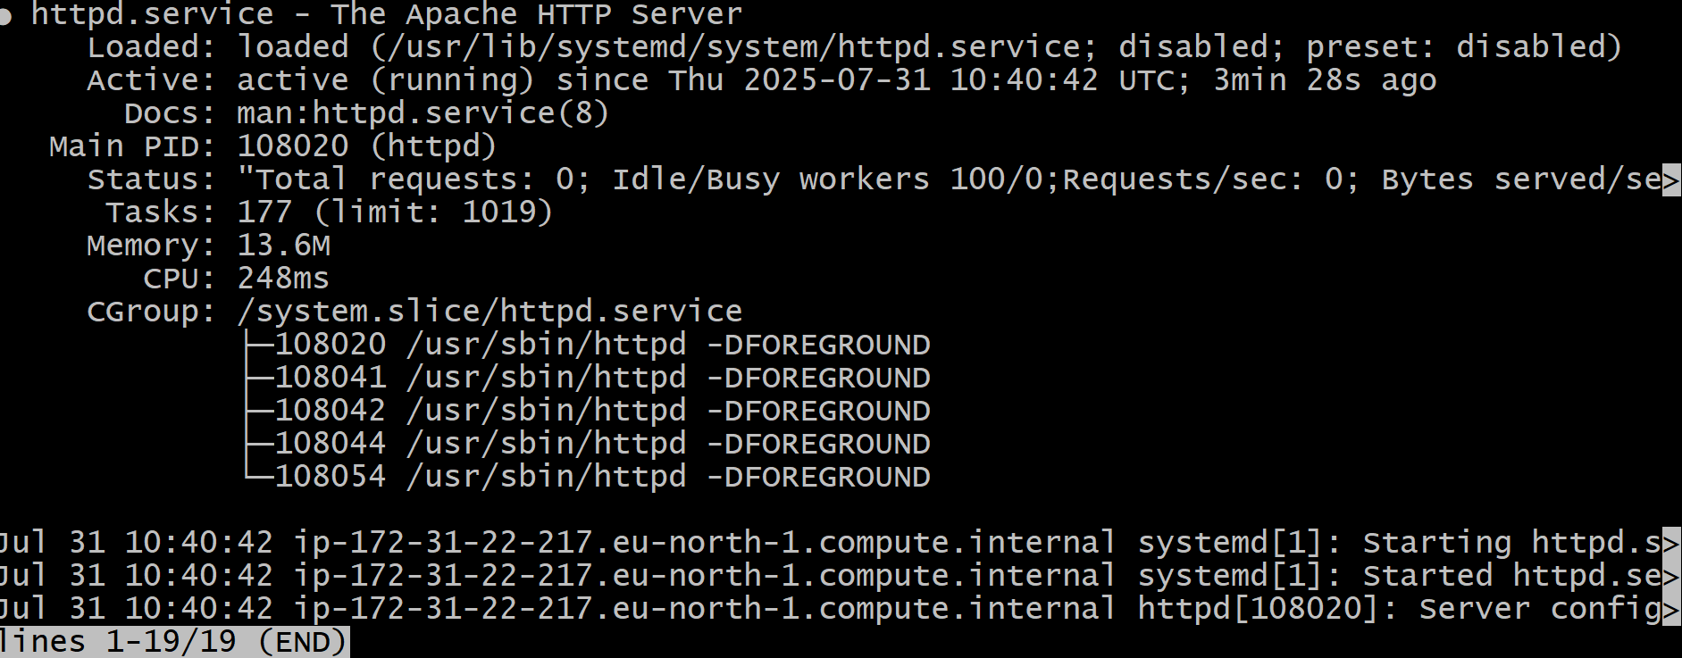
- Deploy a sample index.html file on Apache.
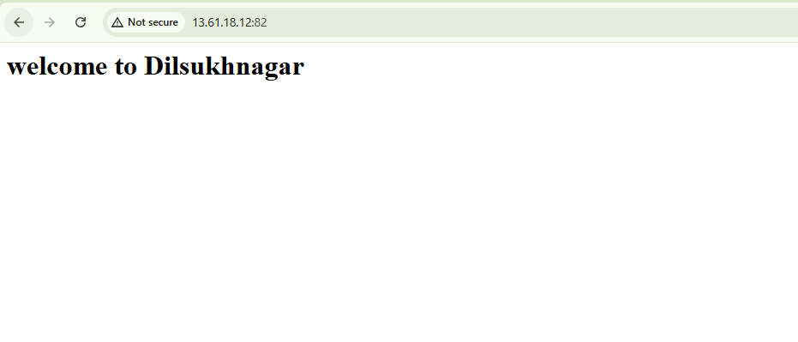
- Install Apache tomcat on port number 8082
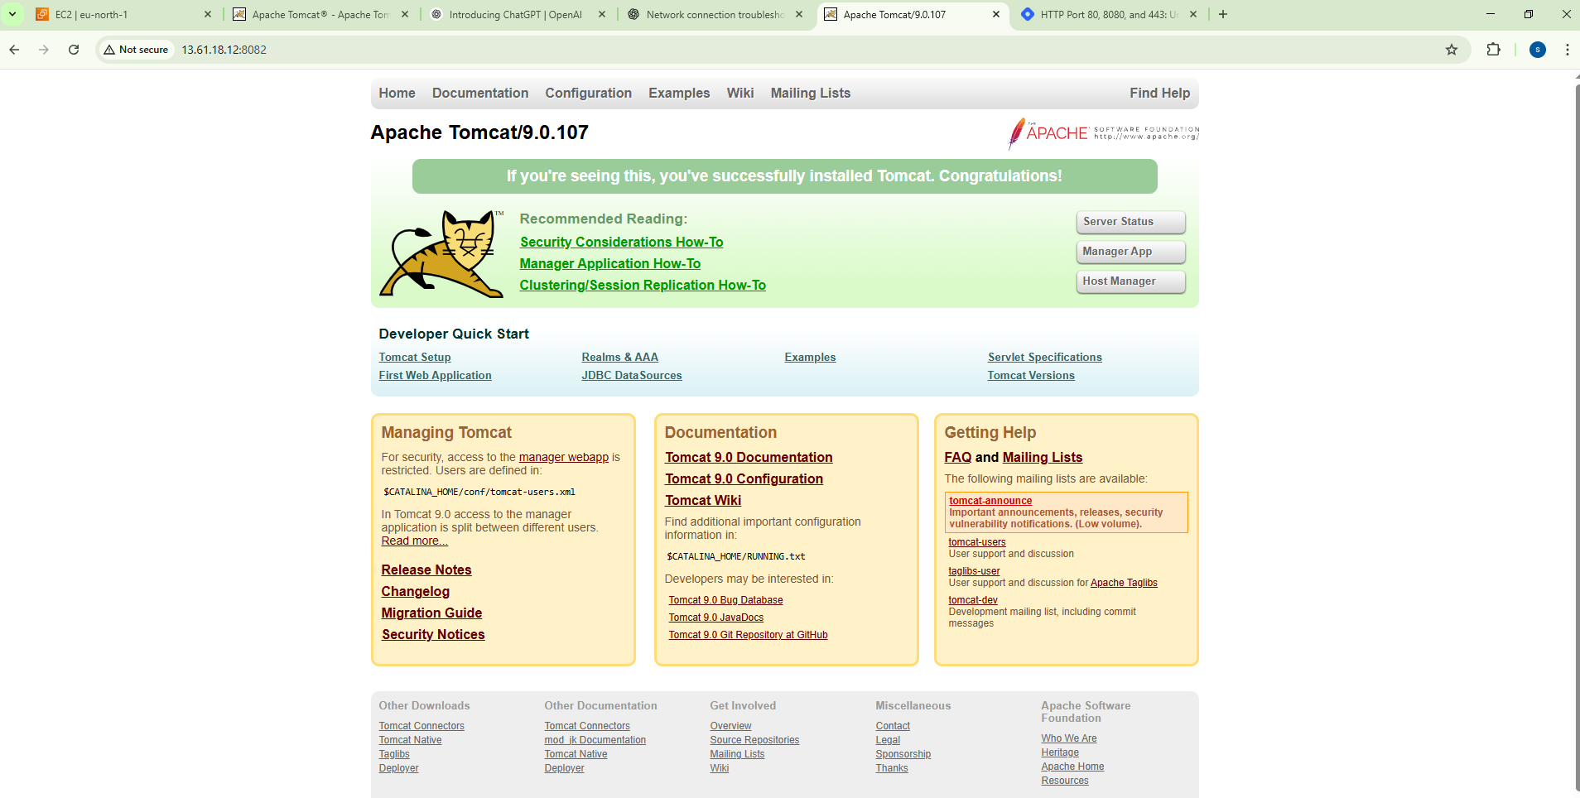
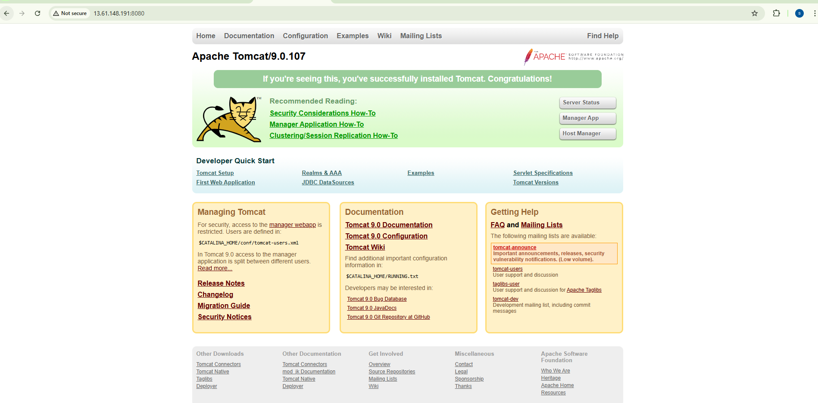
- Deploy a sample app on webapps
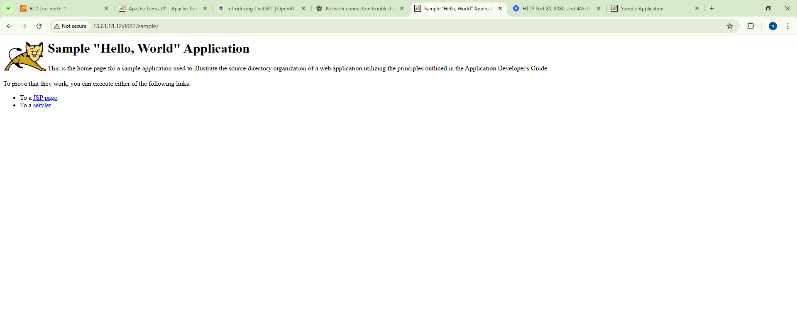
- Create a tomcat.service file for tomcat.
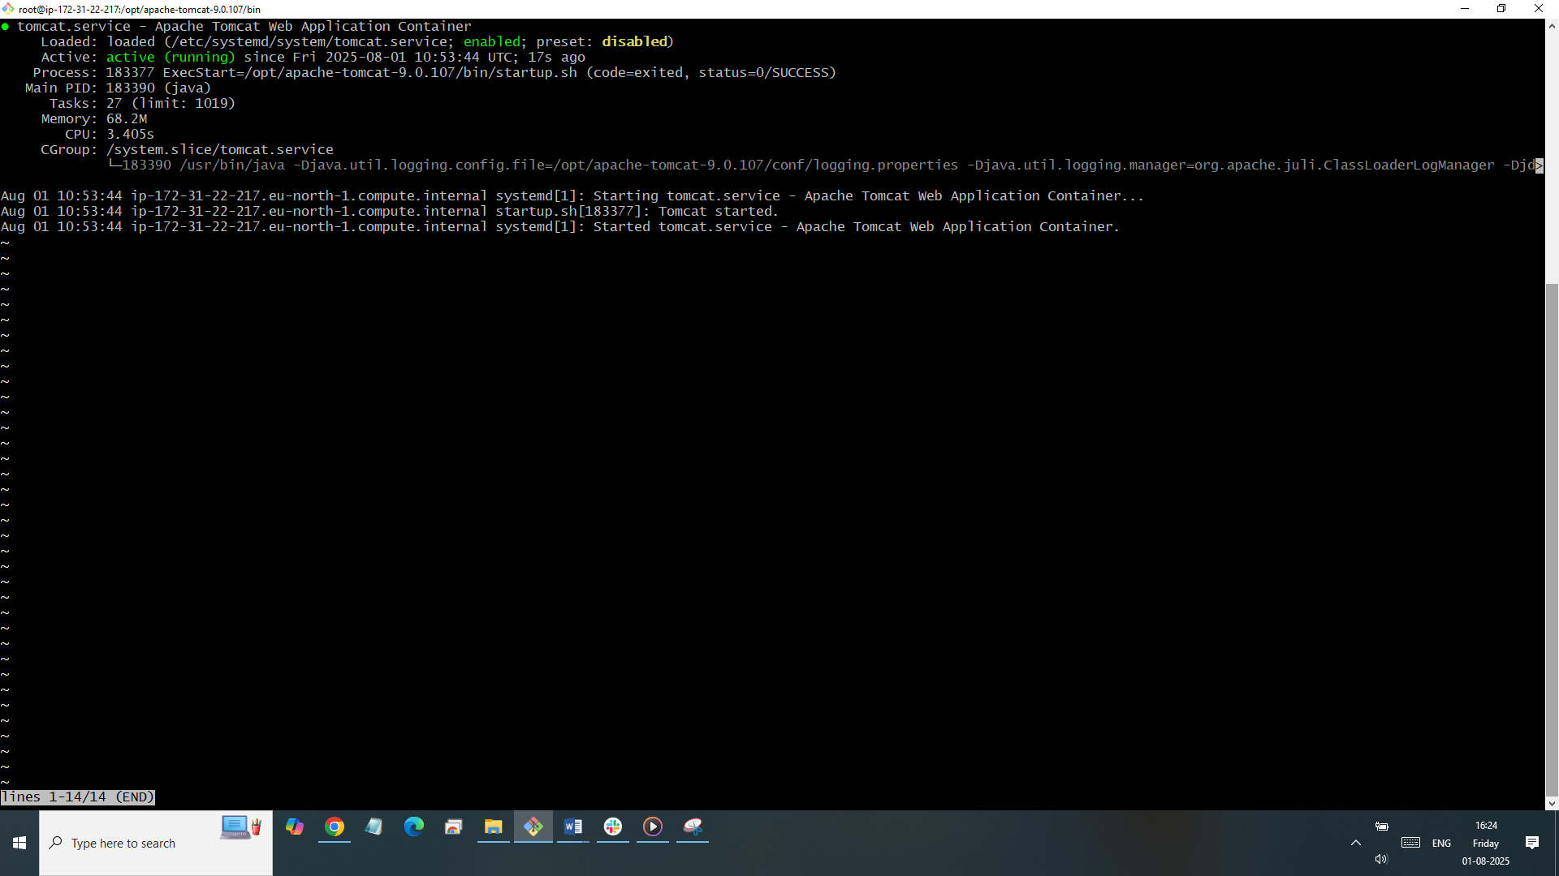
- Configure HA Proxy server
